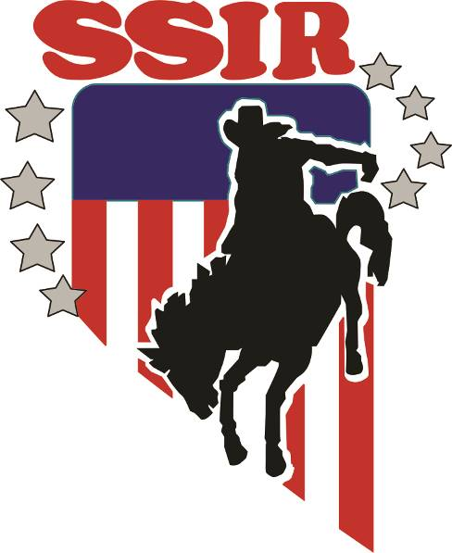
SCHEDULE OF EVENTS FOR ALL PERFORMANCES
SILVER STATE INTERNATIONAL RODEO
37th ANNUAL, June 30 - July 7, 2022
MORNING PERFORMANCE – 9:00 AM
EVENING PERFORMANCE – 7:00 PM
TOP 15 FINALS ON Thursday AT 9:00 AM
ORDER OF EVENTS
Small Arena AM Large Arena AM
HS Pole Bending JHS Team Roping
JHS Pole Bending HS Team Roping
HS Goat Tying HS Steer Wrestling
JHS Girls Goat Tying JHS Bull Riding
JHS Boys Goat Tying JHS Bareback Steer Riding
HS Breakaway Roping JHS Saddle Bronc Steer Riding
HS Tie Down Roping JHS Ribbon Roping
JHS Girls Breakaway HS Barrel Racing
JHS Tie Down Roping JHS Barrel Racing
JHS Boys Breakaway

Small Arena PM Large Arena PM
HS Pole Bending JHS Chute Dogging
JHS Pole Bending HS Bareback Riding
HS Goat Tying HS Saddle Bronc Riding
JHS Girls Goat Tying JHS Team Roping
JHS Boys Goat Tying HS Team Roping
HS Breakaway Roping HS Bull Riding
HS Tie Down Roping JHS Ribbon Roping
JHS Girls Breakaway HS Barrel Racing
JHS Tie Down Roping JHS Barrel Racing
JHS Boys Breakaway

Contestant order will be reversed in the second go around in all events except cutting and reined cow horse. Cutting, Reined Cow Horse awards will be on Saturday, July 2nd at 5:00 PM. First go awards will be on Tuesday, July 5th at 5:30 PM. 2nd go, short go, scholarship and final awards will be at the awards ceremony at approximately 2:00 p.m. on Thursday in the Events Center.
WESTERN ATTIRE REQUIRED AT AWARDS CEREMONIES

